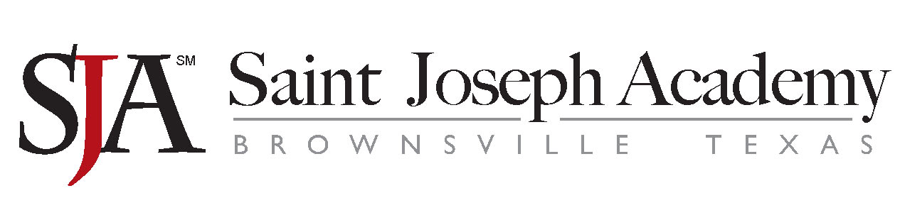
February 21, 2019

Dear Parent or Guardian:

We are pleased to notify you that Saint Joseph Academy has been selected to represent private schools across the nation by participating in the National Assessment of Educational Progress (NAEP) on February 27, 2019. NAEP is the largest nationally representative and continuing assessment of what students in public and private schools know and can do in various subjects. It is administered by the National Center for Education Statistics, within the U.S. Department of Education. NAEP is different from state and school assessments because it provides a common measure of student achievement across the country. The results are released as The Nation’s Report Card, which provides information about student achievement to educators, parents, policymakers, and the public.

Your child will take an assessment in one of the following subjects: mathematics, reading, or science. In addition to subject area questions, NAEP survey questionnaires are voluntarily completed by students. The questionnaires provide valuable information about participating students’ educational experiences and opportunities to learn both in and out of the classroom. More information is available at https://nces.ed.gov/nationsreportcard/parents under the section “What Questions Are on the Test?”

The assessment takes about 120 minutes for most students.

The information collected is used for statistical purposes only.
- Your child’s grades will not be affected.
- Students may be excused for any reason, are not required to complete the assessment, and may skip any question.
- While the assessment is voluntary, NAEP depends on student participation to help policymakers improve education. However, if you do not want your child to participate, please notify me in writing by February 20, 2019.

There is no need to study in preparation for NAEP, but please encourage your child to do his or her best. A brochure that explains what participation in NAEP means for you and your child is available at http://nces.ed.gov/nationsreportcard/pdf/parents/2012469.pdf. Contact Olga Cisneros at 956-542-3581, Ext. 354 or at ocisneros@sja.us if you have any questions. To learn more about private school participation in NAEP visit http://nces.ed.gov/nationsreportcard/participating/private_nonpublic.aspx.

We are excited that our school is participating in NAEP. We know that Saint Joseph Academy's students will show what our nation’s students in private schools know and can do.

Sincerely,
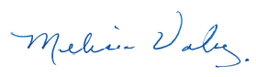
Melissa Valadez

National Center for Education Statistics (NCES) is authorized to conduct NAEP by the National Assessment of Educational Progress Authorization Act (20 U.S.C. §9622) and to collect students’ education records from education agencies or institutions for the purposes of evaluating federally supported education programs under the Family Educational Rights and Privacy Act (FERPA, 34 CFR §§ 99.31(a)(3)(iii) and 99.35). All of the information provided by participants may be used only for statistical purposes and may not be disclosed, or used, in identifiable form for any other purpose except as required by law (20 U.S.C. §9573 and 6 U.S.C. §151). By law, every NCES employee as well as every NCES agent, such as contractors and NAEP coordinators, has taken an oath and is subject to a jail term of up to 5 years, a fine of $250,000, or both if he or she willfully discloses ANY identifiable information about participants. Electronic submission of participant’s information will be monitored for viruses, malware, and other threats by Federal employees and contractors in accordance with the Cybersecurity Enhancement Act of 2015. The collected information will be combined across respondents to produce statistical reports.

